**Observe and understand the process map of the previous two lab programs (Experiment 6 and Experiment 7) using pmap command.**

Io Bound

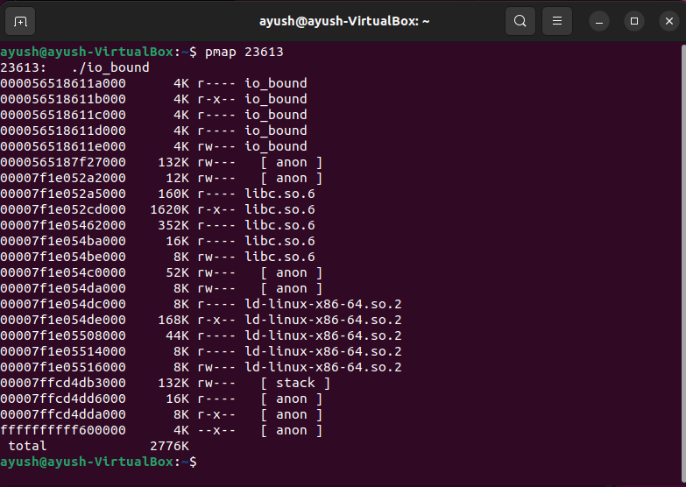

Cpu Bound

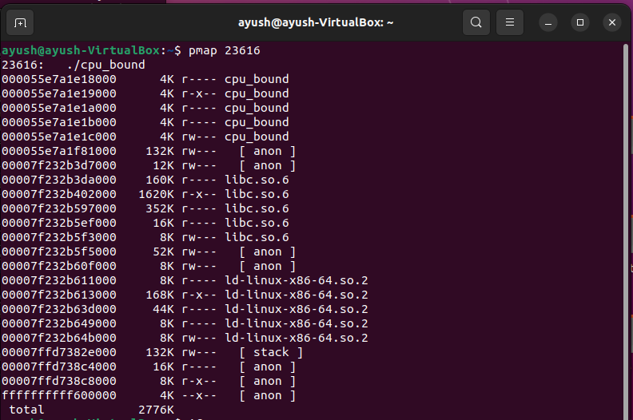

Cpu

